Step 1: Select your State and Constituency and access your Member of Parliament’s profile. In addition to your own Member of Parliament, you can access any MP from any State or Constituency as well.

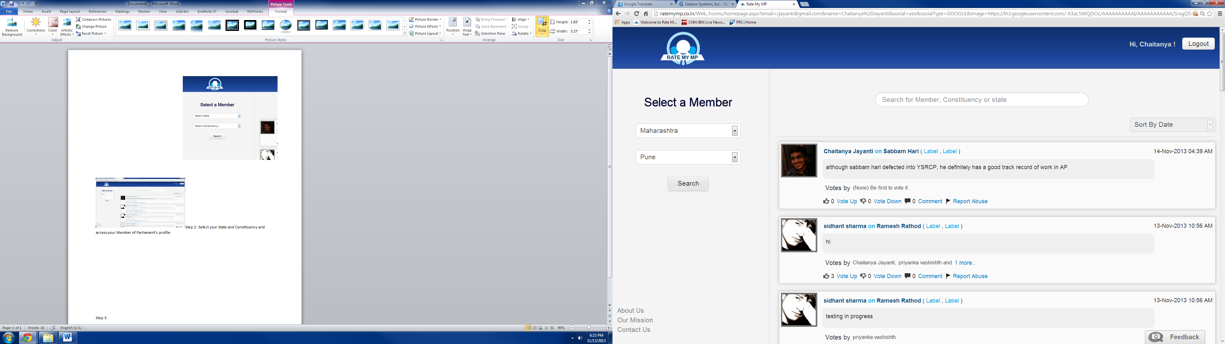

Step 2: Write anything you want about your Member of Parliament. It can be personal experiences you’ve had with the MP, problems you’re experiencing in your constituency, things you’ve read about the MP, or even your own analysis on contemporary issues. **Remember, comments that get 20 Votes Up will be sent directly to the MP, so be sure to write something you think others will agree with**. Categorise your comment as praise, criticism, suggestions, or miscellaneous, and click Post!

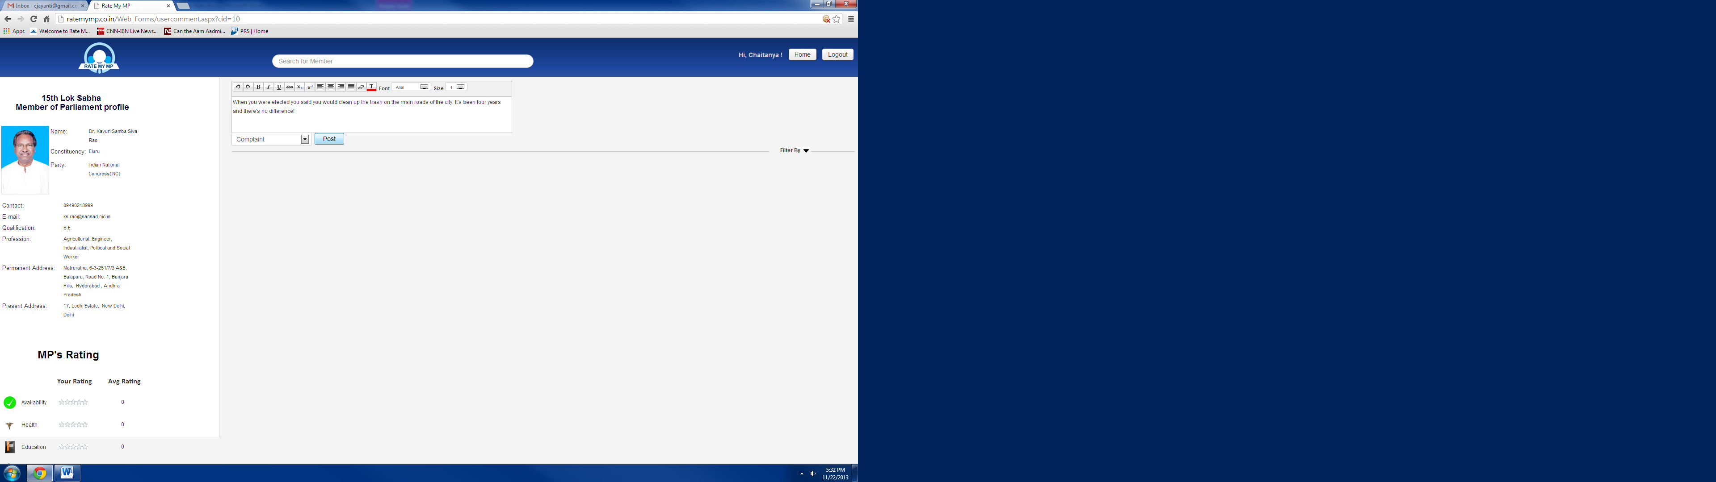

Step 3: Take a look through other comments about your MP! You can sort them by type, date, and popularity. Vote up comments that you agree with and vote down ones that you don’t agree with. These users are part of you constituency too so look out for comments you really like and contact the poster!

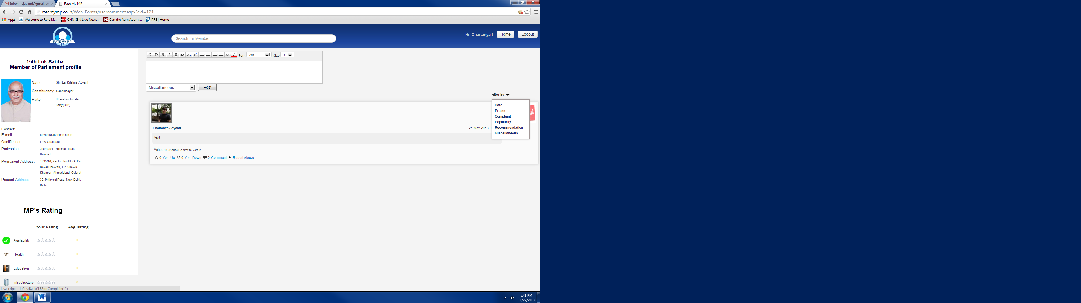

Step 4: Scroll down and Rate Your MP on important performance metrics!

